

“Online Voting System”

Acknowledgement

The Success behind any project always involves many people. The same thing is with us, in fact may be I even forgot many of the names.
But the first personality that comes to my mind is Rajendra Pandey who was my mentor for the project at UPTEC. He has helped me in all the way that a guide can. My sincerer thank for his help & encouragement.

ONCE AGAIN TO ALL OF THEM SINCERELY.

Online Voting System

INDEX

- Introduction.

- Project Description.

- Analysis.

- Why Java Used?
- Client Server Technologies.
- Feasibility Study.
- Hardware & Software Requirements.

- Design Documents.

- E-R Diagram.
- Use Case Diagram.
- Class Diagram.
- Object Diagram.
- Sequence Diagram.
- Collaboration Diagram.
- Activity Diagram.
- Deployment Diagram

- Testing & Debugging Strategies.

- Input & Output Layouts.

- Conclusions & Recommendations.

- Bibliography.

Introduction

Existing System

The Existing System of Election is running manually.
The Voter has to Visit to Booths to Vote a Candidate so there is wastage of Time.
The Voter has to manually register into the Voter List. Also Vote counting has to be done manually.
All the Information of the Voter or Candidate is to be filling in manually.
Voter must be present in his/her Constituency to give his/her Vote.
There are Electronic Voting Machines used which Takes More Cost.

Manual Voting Process

Physically

Visits
Voter

Voter Booth
Enter in Queue.
Wait in queue until
Front queue is empty
Wait for few
Days/month for
Declaring a result.
Registers vote to
Particular one
Candidate.
Voter sees the candidate’s name


Need For the System

It was decided to Computerize the System in order to overcome the following problems:-
- To increase the Voting Percentage.
- To make Voter easy to Vote from anywhere.
- Time Wastage.
- To avoid thing like Booth Capturing.

Scope of the System

The Scope of the System is as Follows:

- Voter can Vote from any where for his/her Constituency.
- Vote count will make easy and fast.
- No any Vote will be rejected.

Goals of the System

Goals of the System are as Follows:

- It Maintains all The Information of all the Candidates and Votes.
- It checks Voter have Voted or Not.
- You can see All the Information Related to any Voting System Online.
- It Increase the Voting Percentage.
- Finally It makes Easy Voting by Avoiding problems like
- Security,
- Booth capturing.

The actual purpose of going for this system is to make the organizational process to get speed up.

Project Descriptions

Overall Description:

Number of Databases:
The project consists of 3 databases which are as follows
Voter:- This Table contain all Voter Details. The Voter is client side Entity and it has Following attributes.

Voter_id* | Voter_Name | Voter_age | Voter_addr

Candidate:- This Table contain Detail information about Candidate. Candidate is Server side Entity. It has following attributes.

Candidate_id* | Candidate_Name | Candidate_dsc | VotingPanel_id

Voting Panel:- Voting Panel contain Different types of Voting Panels,
It is a server side Entity. It has following attributes.
VotingPanel_id* | VotingPanel_Name | VotingPanel_dsc

Property:- Property are the Authentications required for a particular Voting Panel ,It Is a server side Entity. It has following attributes.

Prop_id* | Prop_Name | Min_age_limit | Nationality | VotingPanel_id

Result:- Result table store the Result of Different Voting Panels, it is a server side Entity. It has following attributes.

Result_id* | Result_type | Vote_count | VotingPanel_id

Analysis

Features of the Language Used
In my project, I have chosen Java language for developing the code.

About Java

Initially the language was called as “oak” but it was renamed as “Java” in 1995. The primary motivation of this language was the need for a platform-independent (i.e., architecture neutral) language that could be used to create software to be embedded in various consumer electronic devices.
- Java is a programmer’s language.
- Java is cohesive and consistent.
- Except for those constraints imposed by the Internet environment, Java gives the programmer, full control.
Finally, Java is to Internet programming where C was to system programming.

Importance of Java to the Internet
Java has had a profound effect on the Internet. This is because; Java expands the Universe of objects that can move about freely in Cyberspace. In a network, two categories of objects are transmitted between the Server and the Personal computer. They are: Passive information and Dynamic active programs. The Dynamic, Self-executing programs cause serious problems in the areas of Security and probability. But, Java addresses those concerns and by doing so, has opened the door to an exciting new form of program called the Applet.

Java can be used to create two types of programs
Applications and Applets: An application is a program that runs on our Computer under the operating system of that computer. It is more or less like one creating using C or C++. Java’s ability to create Applets makes it important. An Applet is an application designed to be transmitted over the Internet and executed by a Java –compatible web browser. An applet is actually a tiny Java program, dynamically downloaded across the network, just like an image. But the difference is, it is an intelligent program, not just a media file. It can react to the user input and dynamically change.

Features of Java Security
Every time you that you download a “normal” program, you are risking a viral infection. Prior to Java, most users did not download executable programs frequently, and those who did scanned them for viruses prior to execution. Most users still worried about the possibility of infecting their systems with a virus. In addition, another type of malicious program exists that must be guarded against. This type of program can gather private information, such as credit card numbers, bank account balances, and passwords. Java answers both these concerns by providing a “firewall” between a network application and your computer.
When you use a Java-compatible Web browser, you can safely download Java applets without fear of virus infection or malicious intent.

Portability
For programs to be dynamically downloaded to all the various types of platforms connected to the Internet, some means of generating portable executable code is needed .As you will see, the same mechanism that helps ensure security also helps create portability. Indeed, Java’s solution to these two problems is both elegant and efficient.

The Byte code
The key that allows the Java to solve the security and portability problems is that the output of Java compiler is Byte code. Byte code is a highly optimized set of instructions designed to be executed by the Java run-time system, which is called the Java Virtual Machine (JVM). That is, in its standard form, the JVM is an interpreter for byte code.
Translating a Java program into byte code helps makes it much easier to run a program in a wide variety of environments. The reason is, once the run-time package exists for a given system, any Java program can run on it.
Although Java was designed for interpretation, there is technically nothing about Java that prevents on-the-fly compilation of byte code into native code. Sun has just completed its Just In Time (JIT) compiler for byte code. When the JIT compiler is a part of JVM, it compiles byte code into executable code in real time, on a piece-by-piece, demand basis. It is not possible to compile an entire Java program into executable code all at once, because Java performs various run-time checks that can be done only at run time. The JIT compiles code, as it is needed, during execution.

Java Virtual Machine (JVM)
Beyond the language, there is the Java virtual machine. The Java virtual machine is an important element of the Java technology. The virtual machine can be embedded within a web browser or an operating system. Once a piece of Java code is loaded onto a machine, it is verified. As part of the loading process, a class loader is invoked and does byte code verification makes sure that the code that’s has been generated by the compiler will not corrupt the machine that it’s loaded on. Byte code verification takes place at the end of the compilation process to make sure that is all accurate and correct. So byte code verification is integral to the compiling and executing of Java code.

Overall Description

Java Source
Java Source
Java byte code
Java VM
Java
. Class
Java Source
Java Source
Java Byte Code
Java VM
Java
. Class

Picture showing the development process of JAVA Program
Java programming uses to produce byte codes and executes them. The first box indicates that the Java source code is located in a. Java file that is processed with a Java compiler called javac. The Java compiler produces a file called a. class file, which contains the byte code. The. Class file is then loaded across the network or loaded locally on your machine into the execution environment is the Java virtual machine, which interprets and executes the byte code.

Java Architecture
Java architecture provides a portable, robust, high performing environment for development. Java provides portability by compiling the byte codes for the Java Virtual Machine, which is then interpreted on each platform by the run-time environment. Java is a dynamic system, able to load code when needed from a machine in the same room or across the planet.

Compilation of code
When you compile the code, the Java compiler creates machine code (called byte code) for a hypothetical machine called Java Virtual Machine (JVM). The JVM is supposed to execute the byte code. The JVM is created for overcoming the issue of portability. The code is written and compiled for one machine and interpreted on all machines. This machine is called Java Virtual Machine.

Compiling and interpreting Java Source Code
Source
Code
………..
………..

………..

…………

PC Compiler
Macintosh
Compiler
SPARC
Compiler
Java

Byte code

(Platform
Indepen
dent)
Java
Interpreter
(PC)
Java
Interpreter
(Macintosh)
Java
Interpreter
( Spare )

During run-time the Java interpreter tricks the byte code file into thinking that it is running on a Java Virtual Machine. In reality this could be a Intel Pentium Windows 95 or SunSARC station running Solaris or Apple Macintosh running system and all could receive code from any computer through Internet and run the Applets.

Simple
Java was designed to be easy for the Professional programmer to learn and to use effectively. If you are an experienced C++ programmer, learning Java will be even easier. Because Java inherits the C/C++ syntax and many of the object oriented features of C++. Most of the confusing concepts from C++ are either left out of Java or implemented in a cleaner, more approachable manner. In Java there are a small number of clearly defined ways to accomplish a given task.

Object-Oriented
Java was not designed to be source-code compatible with any other language. This allowed the Java team the freedom to design with a blank slate. One outcome of this was a clean usable, pragmatic approach to objects. The object model in Java is simple and easy to extend, while simple types, such as integers, are kept as high-performance non-objects.

Robust
The multi-platform environment of the Web places extraordinary demands on a program, because the program must execute reliably in a variety of systems. The ability to create robust programs was given a high priority in the design of Java. Java is strictly typed language; it checks your code at compile time and run time.
Java virtually eliminates the problems of memory management and reallocation, which is completely automatic. In a well-written Java program, all run time errors can –and should –be managed by your program.

Client Server Technologies

Client Server:-

Overview :-
With the varied topic in existence in the fields of computers, Client Server is one, which has generated more heat than light, and also more hype than reality. This technology has acquired a certain critical mass attention with its dedication conferences and magazines. Major computer vendors such as IBM and DEC; have declared that Client Servers is their main future market. A survey of DBMS magazine reveled that 76% of its readers were actively looking at the client server solution. The growth in the client server development tools from $200 million in 1992 to more than $1.2 billion in 1996.
Client server implementations are complex but the underlying concept is simple and powerful. A client is an application running with local resources but able to request the database and relate the services from separate remote server. The software mediating this client server interaction is often referred to as MIDDLEWARE.
The typical client either a PC or a Work Station connected through a network to a more powerful PC, Workstation, Midrange or Main Frames server usually capable of handling request from more than one client. However, with some configuration server may also act as client. A server may need to access other server in order to process the original client request.
The key client server idea is that client as user is essentially insulated from the physical location and formats of the data needs for their application. With the proper middleware, a client input from or report can transparently access and manipulate both local database on the client machine and remote databases on one or more servers. An added bonus is the client server opens the door to multi-vendor database access indulging heterogeneous table joins.

What is a Client Server
Two prominent systems in existence are client server and file server systems. It is essential to distinguish between client servers and file server systems. Both provide shared network access to data but the comparison dens there! The file server simply provides a remote disk drive that can be accessed by LAN applications on a file-by-file basis. The client server offers full relational database services such as SQL-Access, Record modifying, Insert, Delete with full relational integrity backup/ restore performance for high volume of transactions, etc. the client server middleware provides a flexible interface between client and server, who does what, when and to whom.

Why Client Server
Client server has evolved to solve a problem that has been around since the earliest days of computing: how best to distribute your computing, data generation and data storage resources in order to obtain efficient, cost effective departmental an enterprise wide data processing. During mainframe era choices were quite limited. A central machine housed both the CPU and DATA (cards, tapes, drums and later disks). Access to these resources was initially confined to batched runs that produced departmental reports at the appropriate intervals. A strong central information service department ruled the corporation. The role of the rest of the corporation limited to requesting new or more frequent reports and to provide hand written forms from which the central data banks were created and updated. The earliest client server solutions therefore could best be characterized as “SLAVE-MASTER”.

Time-sharing changed the picture. Remote terminal could view and even change the central data, subject to access permissions. And, as the central data banks evolved in to sophisticated relational database with non-programmer query languages, online users could formulate adhoc queries and produce local reports with out adding to the MIS applications software backlog. However remote access was through dumb terminals, and the client server remained subordinate to the Slave\Master.
Feasibility Study

The success of any system resides particularly form the user point that is, does the system provides you the proper information, easy to operate. The crucial part is deciding upon the requirement, to provide him the possible solution .The system should meet the user needs, the system should be economical. the system be easily maintained and enhanced.
Feasibility study is conducted to test the operational, economical and technical feasibility of the system.

- Operational Feasibility :
The system provides a user-friendly interface and is therefore easy to use. Operating the system requires no programming knowledge anybody with basic computing knowledge can use the system. Therefore the system is operationally feasible.

- Economic Feasibility :
Apart from the development cost and the cost incurred in setting up resource to use the system, the system helps saving administrative expenses on phones/Faxes/personal visits. But the cost incurred in the
Developing and setting up necessary Hardware to use the system is unavoidable. The cost involved in developing and implementing the system is not high, the system definitely helps improving processes. The system is developed using software which is easily available everywhere.
The System being on-line, error detection is speedy resulting in saving man-hours to produce error free output.
After rectifying error.Ultimetly the basic aim of the developer is to increase Customer satisfaction. So the system is economically feasible.

- Technical Feasibility :
As the system is developed using java, it is platform independent. So the users of the system can have average processing capabilities, running on any platforms. Server need to have higher processing capabilities as at a time many use the system simultaneously. The technology used is one of the latest hence the system is also technically feasible.

Hardware & Software Specifications

Required Hardware:

- Pentium III Processor.
- 128 MB RAM.
- 10GB Hard Disk space.
- Ethernet card with an Internet and Internet zone.

Required Software:

- Windows 2000 XP, Windows 98 operating system.
- Internet explorer 5.0 and Netscape navigator.
- UML VP Suite.

Documents Design

Design Document :

  - The entire system is projected with a physical diagram which specifics the actual storage parameters that are physically necessary for any database to be stored on to the disk. The overall systems existential idea is derived from this diagram.

  - The relation upon the system is structure through a conceptual ER-Diagram, which not only specifics the existential entities but also the standard relations through which the system exists and the cardinalities that are necessary for the system state to continue.

ER-Diagrams
  - The entity Relationship Diagram (ERD) depicts the relationship between the data objects.
  - The ERD is the notation that is used to conduct the date modeling activity the attributes of each data
  - object noted is the ERD can be described resign a data object
Descriptions.
  - The set of primary components that are identified by the ERD are
◆ Data object  Relationships
◆ Attributes  Various types of indicators.
  - The primary purpose of the ERD is to represent data objects and
  - Their relationships.

Unified Modeling Language Diagrams
  - The unified modeling language allows the software engineer to
Express an analysis model using the modeling notation that is governed by a set of syntactic semantic and pragmatic rules.
  - A UML system is represented using five different views that describe the system from distinctly different perspective. Each view is defined By a set of diagram, this is as follows.
  - User Model View
    - This view represents the system from the users’ perspective.
    - The analysis representation describes a usage scenario from the End-users perspective.
Structural model view
- In this model the data and functionality are arrived from inside the system.
◆ This model view models the static structures.
Behavioral Model View
- It represents the dynamic of behavioral as parts of the system, depicting the interactions of collection between various structural Elements described in the user model and structural model view.
Implementation Model View
  - In this the structural and behavioral as parts of the system are represented as they are to be built.
Environmental Model View
In this the structural and behavioral aspects of the environment in which the system is to be implemented are represented.
UML is specifically constructed through two different domains they are

  - UML Analysis modeling, which focuses on the user
Model and structural model views of the system.
  - UML design modeling, which focuses on the behavioral
Modeling, implementation modeling and environmental Model views.

Use Case Diagrams
Use cases model the system from the end users point of view, with the
following objectives
- To define the functional and operational requirements
of the system by defining a scenario of usage.
- To provide a class and unambiguous description
of how the end user and the system interact with one
another.
- To provide a basis for validation testing.
Use Cases
The actors who have been recognized within the system are
- System administrator
- Voter

Collaboration Diagram:

A Collaboration Diagram show the interaction organized around the object in the interaction and their links
To each other. Unlike sequence diagram the collaboration diagram show the relationship among the relation
Ship among the Object. Collaboration Diagram does not show the time as, Separate dimension .So,
Sequence number determines the sequence of messages. Collaboration diagram cross between the
Symbolic diagram and sequence diagram.

Uses:
1. Describe the specific scenario by duplicate the moment of messages between the object.
2. Show the spatial organization of object and there interaction rather than interaction.

View: Dynamic.

Sequence Diagram:

UML Sequence Diagram is the Dynamic Modeling technique as are, Collaboration and Activity Diagram.
It Validate and Flush the Logic of Usage scenario. Sequence diagram show the object and messages involve in
An interaction it shows the timing of messages but not relationship among the object.

Class Diagram:

Class Diagram describe the static nature of the system of the system .It describe the type of object in the system
And there static relationship, you can specify the characteristic and process it can carry out (operation).
The class is group of object with similar properties and common behavior (operations), common relationship
To the other object and common semantic. In Class diagram following are different visibility modes,

- + public
- # protected
- – private
- $ static attribute
- / Derived attribute
- * Primary Key

Use Case Diagram:

A use case is a set of scenario that describe on interaction between the user and system. A use case diagram.
Show the relationship between the actors and use cases. Three main components are,
- Actor
- Use cases
- System Boundary

Activity Diagram:

Activity diagram are the dynamic modeling technique. It describe the activity of control and it can initiate
The control activity. It can model the flow of control activity to activity. An activity represents the some
Class operation in the system that result is change in the state of system.
It is used to model work flow and business model and interaction of internal operation because activity
Diagram is special kind of state chart diagram.

Testing Strategies & Debugging

Testing
Testing is the process of detecting errors. Testing performs a very critical role for quality assurance and for ensuring the reliability of software. The results of testing are used later on during maintenance also.

Psychology of Testing
The aim of testing is often to demonstrate that a program works by showing that it has no errors. The basic purpose of testing phase is to detect the errors that may be present in the program. Hence one should not start testing with the intent of showing that a program works, but the intent should be to show that a program doesn’t work. Testing is the process of executing a program with the intent of finding errors.

Testing Objectives
The main objective of testing is to uncover a host of errors, systematically and with minimum effort and time. Stating formally, we can say,
- Testing is a process of executing a program with the intent of finding an error.
- A successful test is one that uncovers an as yet undiscovered error.
- A good test case is one that has a high probability of finding error, if it exists.
- The tests are inadequate to detect possibly present errors.
- The software more or less confirms to the quality and reliable standards.

Levels of Testing
In order to uncover the errors present in different phases we have the concept of levels of testing. The basic levels of testing are as shown below…
Acceptance Testing
System Testing
Integration Testing
Unit Testing

Client Needs

Requirements

Design

Code

System Testing
The philosophy behind testing is to find errors. Test cases are devised with this in mind. A strategy employed for system testing is code testing.

Code Testing:
This strategy examines the logic of the program. To follow this method we developed some test data that resulted in executing every instruction in the program and module i.e. every path is tested. Systems are not designed as entire nor are they tested as single systems. To ensure that the coding is perfect two types of testing is performed or for that matter is performed or that matter is performed or for that matter is performed on all systems.

Types of Testing
- Unit Testing
- Link Testing

Unit Testing
Unit testing focuses verification effort on the smallest unit of software i.e. the module. Using the detailed design and the process specifications testing is done to uncover errors within the boundary of the module. All modules must be successful in the unit test before the start of the integration testing begins.
In this project each service can be thought of a module. There are so many modules like Login, HWAdmin, MasterAdmin, Normal User, and PManager. Giving different sets of inputs has tested each module. When developing the module as well as finishing the development so that each module works without any error. The inputs are validated when accepting from the user.
In this application developer tests the programs up as system. Software units in a system are the modules and routines that are assembled and integrated to form a specific function. Unit testing is first done on modules, independent of one another to locate errors. This enables to detect errors. Through this error resulting from interaction between modules initially avoided.

Link Testing
Link testing does not test software but rather the integration of each module in system. The primary concern is the compatibility of each module. The Programmer tests where modules are designed with different parameters, length, type etc.

Integration Testing
After the unit testing we have to perform integration testing. The goal here is to see if modules can be integrated properly, the emphasis being on testing interfaces between modules. This testing activity can be considered as testing the design and hence the emphasis on testing module interactions.
In this project integrating all the modules forms the main system. When integrating all the modules I have checked whether the integration effects working of any of the services by giving different combinations of inputs with which the two services run perfectly before Integration.

System Testing
Here the entire software system is tested. The reference document for this process is the requirements document, and the goal us to see if software meets its requirements.

Acceptance Testing
Acceptance Test is performed with realistic data of the client to demonstrate that the software is working satisfactorily. Testing here is focused on external behavior of the system; the internal logic of program is not emphasized.
In this project ‘Network Management of Database System’ I have collected some data and tested whether project is working correctly or not.
Test cases should be selected so that the largest number of attributes of an equivalence class is exercised at once. The testing phase is an important part of software development. It is the process of finding errors and missing operations and also a complete verification to determine whether the objectives are met and the user requirements are satisfied.

White Box Testing
This is a unit testing method where a unit will be taken at a time and tested thoroughly at a statement level to find the maximum possible errors. I tested step wise every piece of code, taking care that every statement in the code is executed at least once. The white box testing is also called Glass Box Testing.
I have generated a list of test cases, sample data. which is used to check all possible combinations of execution paths through the code at every module level.

Black Box Testing
This testing method considers a module as a single unit and checks the unit at interface and communication with other modules rather getting into details at statement level. Here the module will be treated as a block box that will take some input and generate output. Output for a given set of input combinations are forwarded to other modules.

Criteria Satisfied by Test Cases
        - Test cases that reduced by a count that is greater than one, the number of additional test cases that much be designed to achieve reasonable testing.
        - Test cases that tell us something about the presence or absence of classes of errors, rather than an error associated only with the specific test at hand.

Input & Output Layout

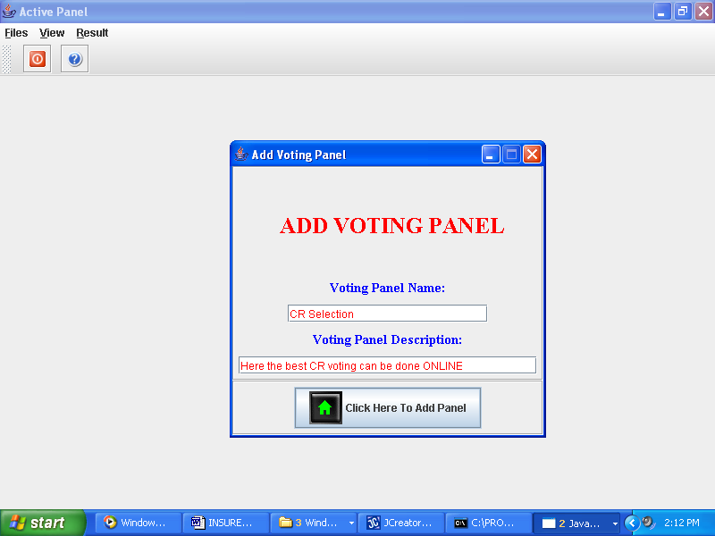

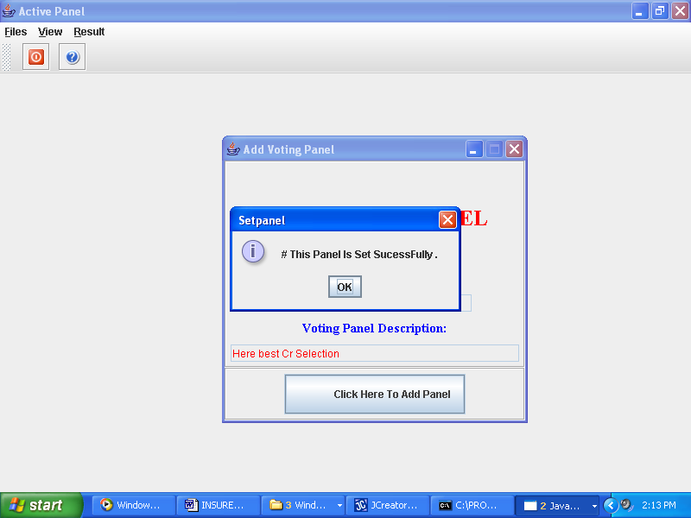

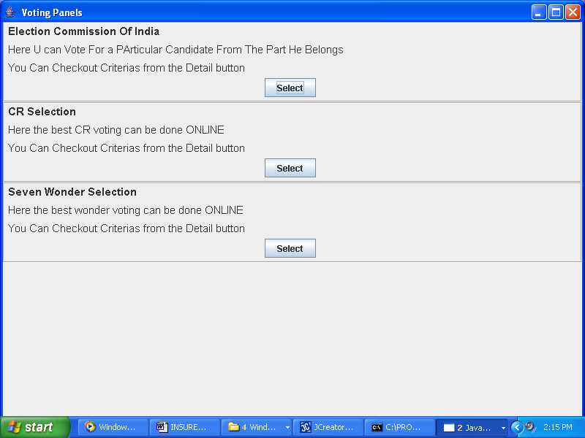

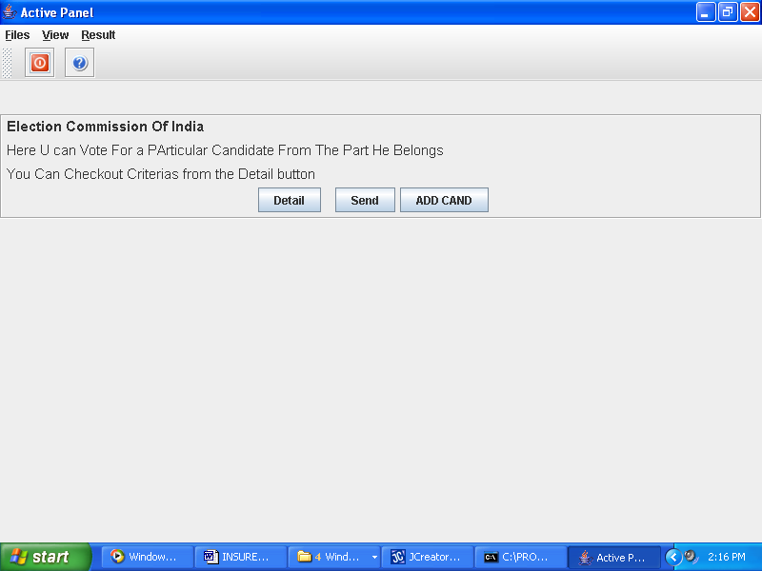

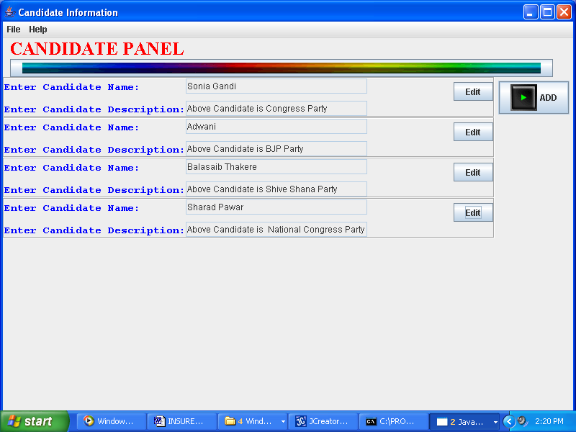

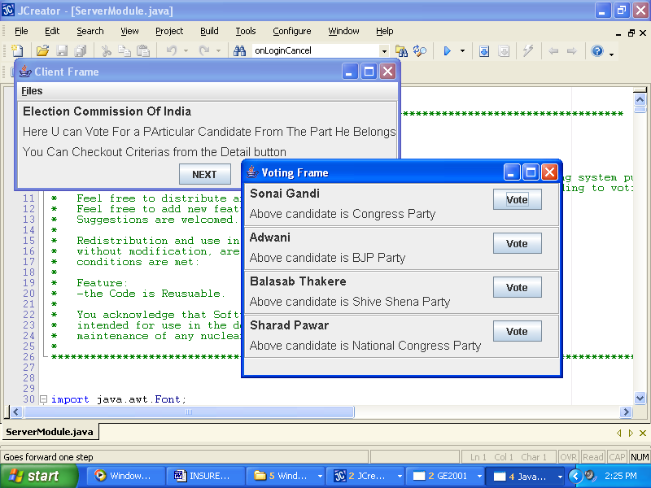

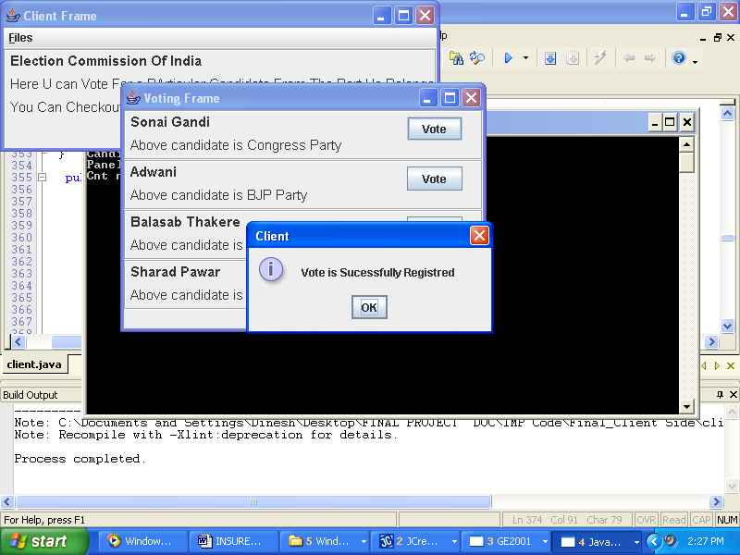

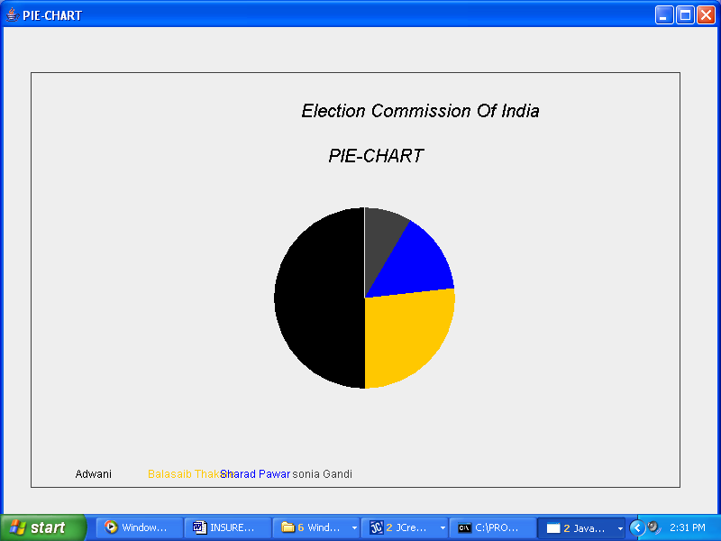

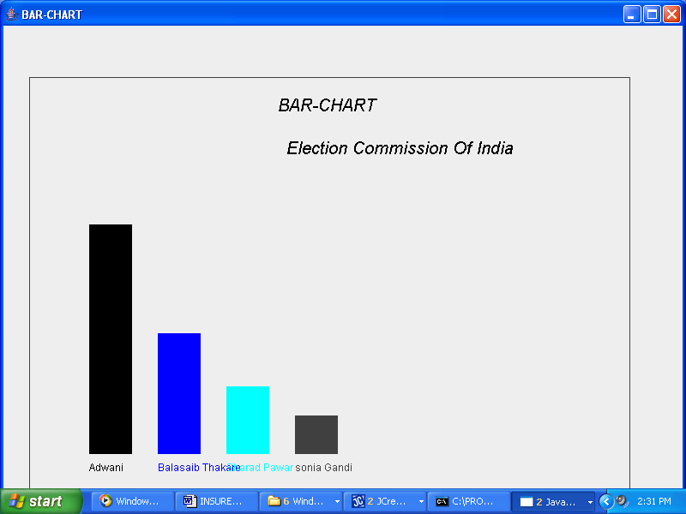

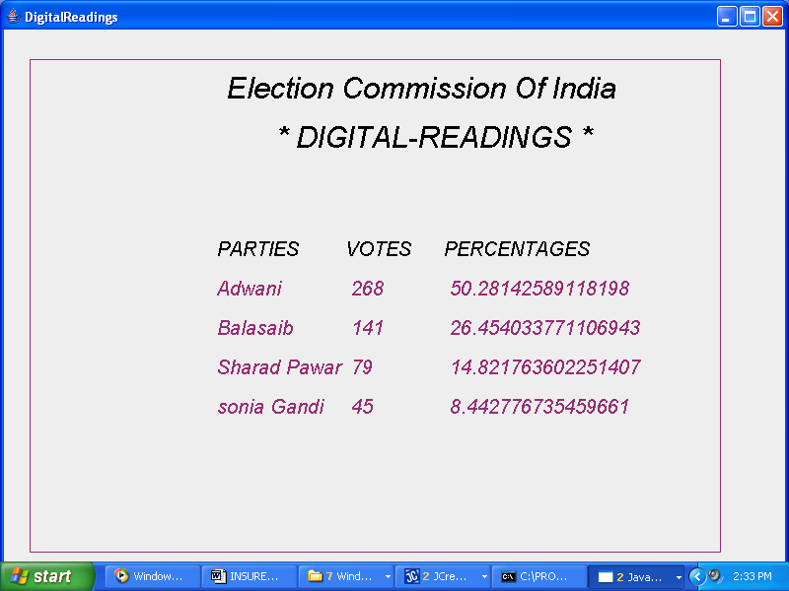

Conclusions & Recommendation

Conclusions And Recommendations :-

The entire project has been developed and deployed as per the requirements
Stated by the user, it is found to be bug free as per the testing standards that is implemented. Any specification-untraced errors will be concentrated in the coming versions, which are planned to be developed in near future. The system at present does not take care off the money payment methods, as the consolidated constructs need SSL standards and are critically to be initiated in the first face; the application of the credit card transactions is applied as a developmental phase in the coming days. The system needs more elaborative technicality for its inception and evolution.
Bibliography:-
References for the Project Development were taken from the
Following Books and Web Sites.
JAVA Technologies
JAVA Complete Reference, JAVA2 __________________ By Herbert Schildt
JAVA2 Networking ___________________By Pistoria
JAVA server pages ___________________By Larne Pekowsley
Black Java

JDBC
Java Database Programming with JDBC _____________By Patel moss.
Software Engineering ____________By Roger Pressman

